Remote Router Install Quick Start Guide

Before Starting

Before starting this install you will need to gather the information on the Routers that you use. For example, if you have 2 routers you will need the following:
For the Remote Router you will need the:
- Remote Router (RR) Name
- Remote Router Domain

For each Router (1 or more) that the Remote Router will subscribe to you will need:
- Router Server IP Address
- Router Server Port

If you are already using a remote router at your location and it is running as an application at your site (anything installed before July of 2009), you can find the information that you need in the remote.ini file. If you don’t have a previously installed Remote Router, ask your Account Manager for this information. The remote.ini file is located in the folder that contains rrs.exe. Open the remote.ini file in any text editor and write down the information for each of the servers. A sample is shown below. The highlighted sections are what you are interested in:

[Remote]
"Market Hours Stop"=dword:00000640
"Name"="testremote"
"MaxPoolSize"=dword:000186a0
"Refresh Symbols Time"=dword:000000e6
"SortTickBufferSize"=dword:00004e20
"NumPacketsPerWrite"=dword:00000008
"Main Queue Size"=dword:00040000
“Domain"="testdomain"
"NumberofDomesticDOBs"=dword:00000001
"AllowSymbolResolutionWithoutRights"=dword:00000000
"ServeOptions"=dword:00000001
"NumCFSConsecutiveTransReqeusts"=dword:000001f4
"Dont Support Customer Fields"=dword:00000000
[Remote\Router]
[Remote\Router\Server #2]
"Port"=dword:000015e0
"Address"="10.10.Y.YYY"
[Remote\Router\Server #1]
"Port"=dword:000015e0
"Address"="10.10.X.XXX"

Note: The port is in hexadecimal in the remote.ini file. It must be entered in decimal in the RRS install. So it must be converted. In the example above the Hexadecimal value of 000015e0 is equal to 5600 in decimal (port 5600 is almost always used).

The result of the example above would result in the following:
- Remote Router Name testremote
- Remote Router Domain testdomain

- Router #1:
  - IP Address of Router #1 10.10.X.XXX
  - Port for Router r#1 5600
- Router #2:
  - IP Address of Router #2 10.10.Y.YYY
  - Port for Router # 2 5600

Installation

Run the Remote Router Install executable to install the any or all of the following:
- Remote Router (32 & 64 bit versions)
- Server Client Admin Tool
- Client Admin Service

The executable will usually have the format of RR Admin_Windows_xxxxxxxxx.exe. The install must be run on the machine that the apps are to be installed on.

There are two sections to this guide.
- Installing a new router over an existing one
- Initial (New) Installtion

The first is for people who already have a remote router installed. The “Installing a new Remote Router (RRS) over an existing RRS” section will walk you through installing a new router on a machine that already has a remote router installed.
The second section titled “Initial (New) Installtion” will walk you through intalling a remote router on a machine that does not have a pervious version of the remote router on it.

Installing a new Remote Router (RRS) over an existing RRS
Begin installation by downloading and running the .exe on the machine that the apps are to be installed.
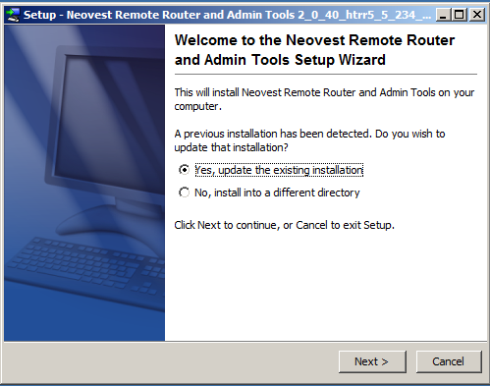

Select “Yes, update the existing installation” to replace your current router. Choose Next.

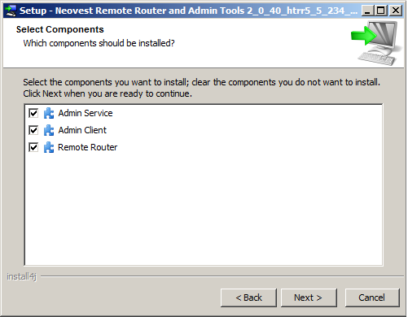
In most cases you will install all items in the list in order to update them at the same time. If you only want to update the Remote Router you would only leave Remote Router checked.

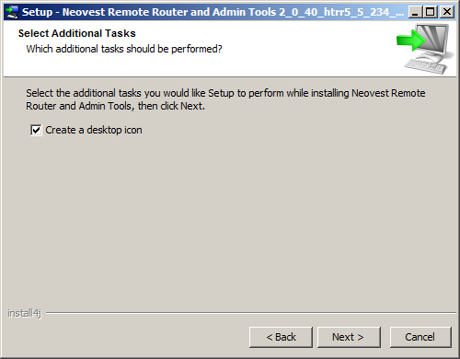
Choose if you would like shortcut icons to appear on your desktop, then Click Next.

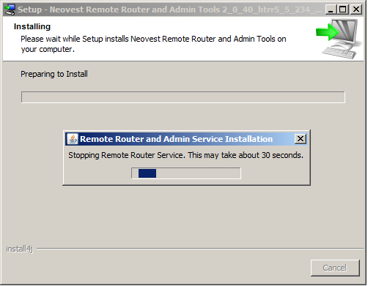
If you currently have a router running the install will first need to shut it down. This will happen automatically. It may take up to several minutes to shut down the previous router.

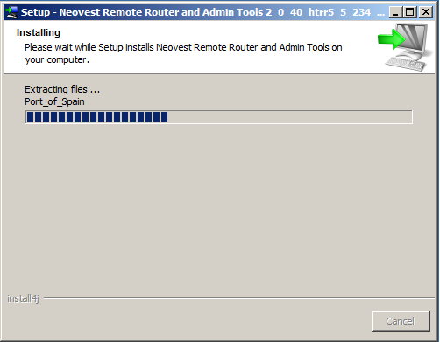
The installer will then extract and install the apps you selected.

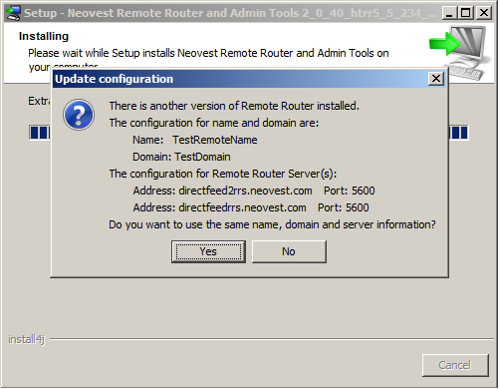
Click yes, unless you want to change your current configuration for this new install.
In the case that you click “No” and you want to update the configuration, you will be prompted for additional information as if this was a New installation. See the Initial (New) Installtion Section.
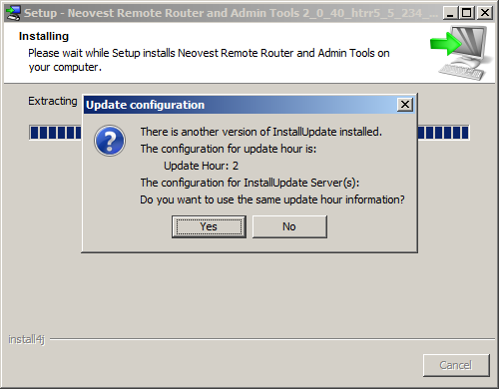
Click yes if you want to perserve your current settings for automaticly updating your remote router. Please note that this is only for configuration purposes, and does not enable the automatic update. If you do not want to enable the auto update feature you may disable it in the next prompt.
In the case that you click “No” and you wish to reconfigure the automatic update settings, you will be prompted for additional information as if this was a New installation. See the Initial (New) Installtion Section.
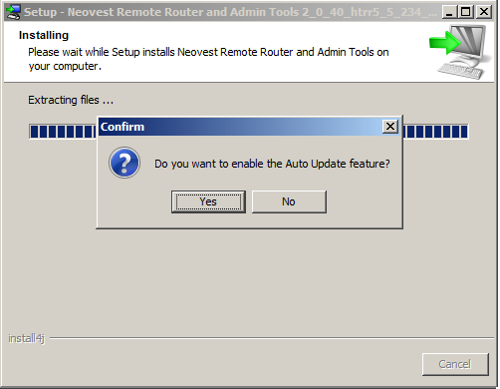
Click “Yes” to enable the auto update feature.

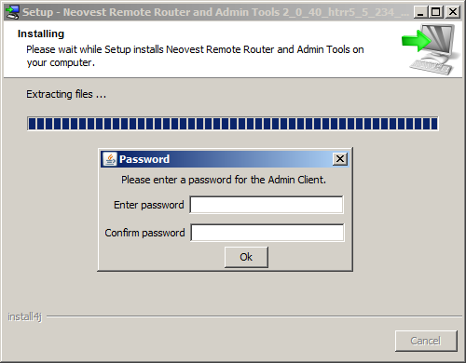
If you selected to install the Admin Client then you will be presented with a prompt asking for a new password. This will set the password for the new Admin Client to the one entered into the prompt.

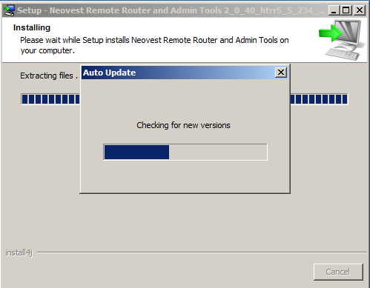
The installer will then check to insure the remote router being installed is the latest version. If there is a newer version of the remote router available then the newest version will be downloaded and installed.

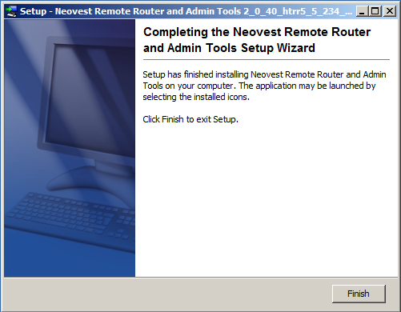
You have completed the installation. You will not need to restart the machine.

Initial (New) Installation
Begin installation by downloading and running the .exe on the machine that the apps are to be installed.
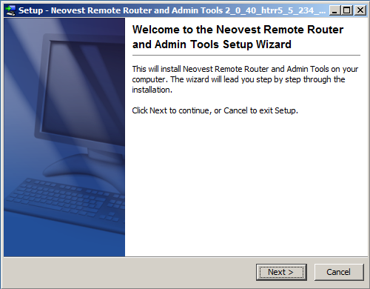
Choose Next. In the next dialog box, you will then be asked what directory to install the Remote router and Admin tools.

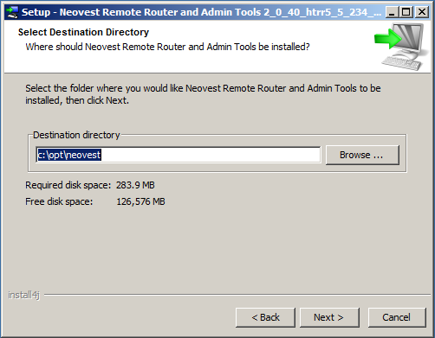
You can keep the same directory or browse to select a different directory to install into. The install wizard will then prompt you with a screen to select the applications to be installed.

In most cases you will install all items in the list in order to update them at the same time. If you only want to update the Remote Router you would only leave Remote Router checked.

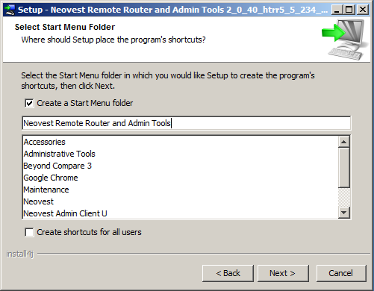
Choose how you want it to display in your shortcuts, start menu, desktop, etc. Click Next.

Choose if you would like shortcut icons to appear on your desktop, then Click Next.

The install will then extract and install the apps you selected and you will see a screen like this one.

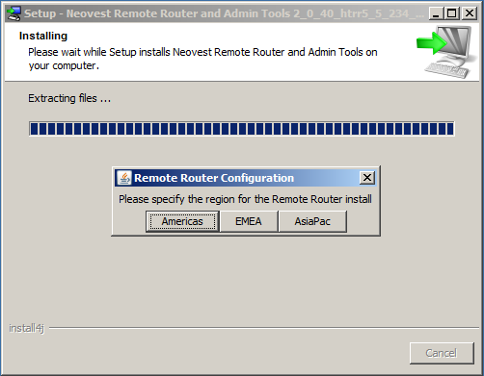
Select the region the remote router will run in.
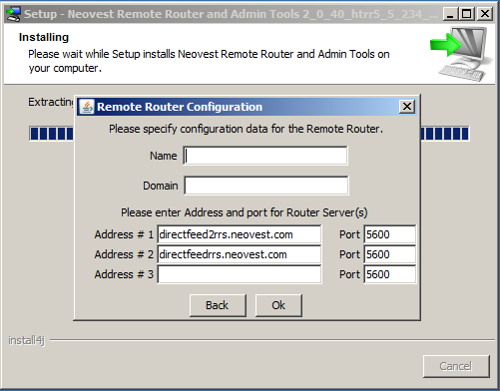
You will then enter into the screen above the following pieces of information
For the Remote Router you will need to enter the:
- Remote Router (RR) Name
- Remote Router Domain

For each Router (1 or more) connecting to the remote router you will need:
- Router Server IP Address
- Router Server Port

Note: Preferred (but not required) Router addresses are shown below for each region (all use port 5600):
- Americas:
directfeed2rrs.neovest.com
directfeedrrs.neovest.com

- EMEA:
ukdirectfeed.neovest.com
directfeed2rrs.neovest.com
directfeedrrs.neovest.com

- Asia:
hkdirectfeed2.neovest.com
hkdirectfeed.neovest.com
directfeed2.neovest.com, or
directfeed.neovest.com

Then press “OK”

The Auto Update feature will allow the remote router to check to see if a newer version of the router is available. If a new version is available it will be downloaded and installed automatically. Click “Yes” to enable the Auto Update feature.
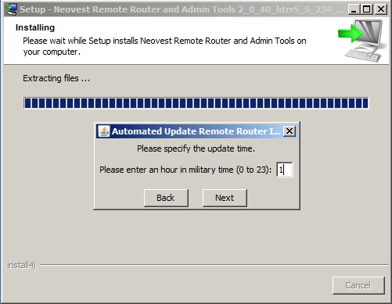
You will then be able to specify at what time the remote router is allowed to check for newer versions. Please note that you must enter the time in a simplified 24 hour format. This means that 1:00 A.M. would be simply 1, and 2:00 P.M. would be 14. Click Next
You will be prompted for a password to protect your Admin Client. Enter a password and then click “Ok”.

The installer will then check to insure the remote router being installed is the latest version. If there is a newer version of the remote router available then the newest version will be downloaded and installed.

You have completed the installation. You will not need to restart the machine.

